Gamma function

|  |  |  |  |
| --- | --- | --- | --- |
|  |  |  |  |
|  |  |  |  |
|  |  |  |  |
|  |  |  |  |
|  |  |  |  |
|  |  |  |  |
|  |  |  |  |
|  |  |  |  |

[Gamma Function of One Half - ProofWiki](https://proofwiki.org/wiki/Gamma_Function_of_One_Half)

[analysis - Why is $\Gamma\left(\frac{1}{2}\right)=\sqrt{\pi}$? - Mathematics Stack Exchange](https://math.stackexchange.com/questions/215352/why-is-gamma-left-frac12-right-sqrt-pi)

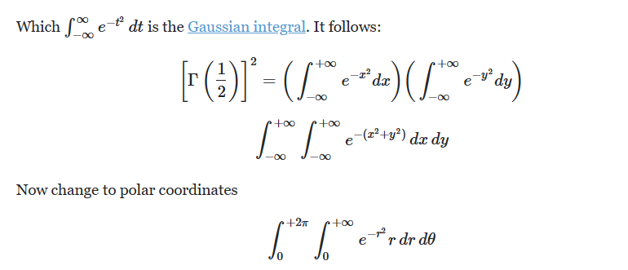

[integration - Prove that $\Gamma(p) \cdot \Gamma(1-p)=\frac{\pi}{\sin (p\pi)}$ for $p \in (0,\: 1)$ - Mathematics Stack Exchange](https://math.stackexchange.com/questions/714482/prove-that-gammap-cdot-gamma1-p-frac-pi-sin-p-pi-for-p-in-0)

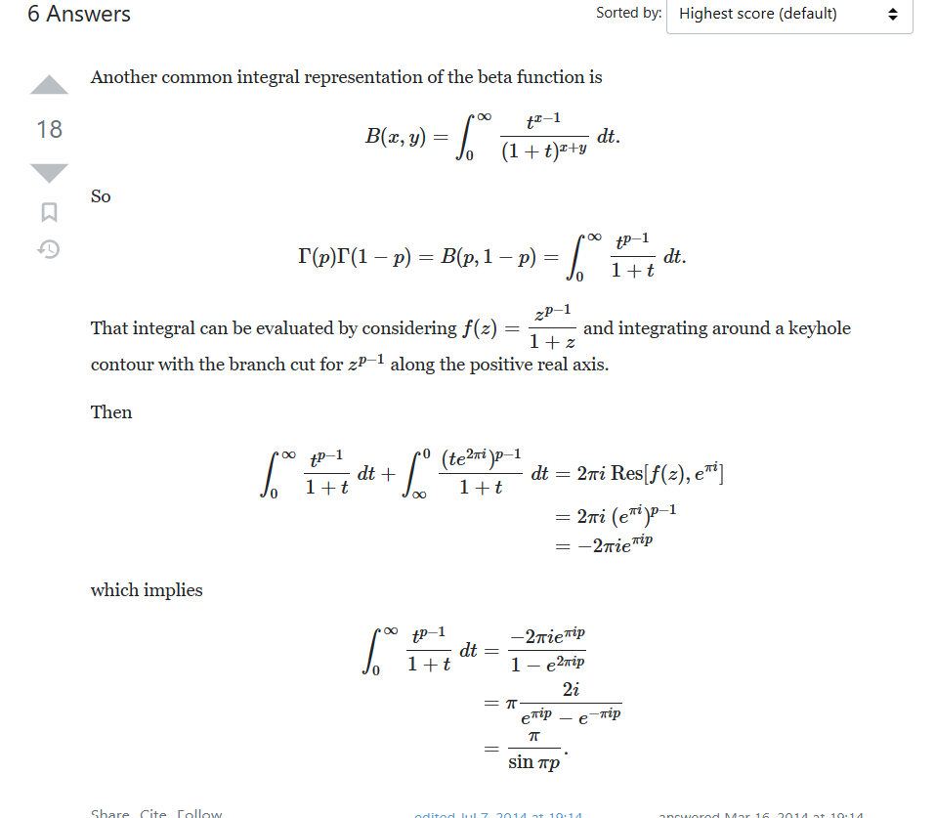

$$Use Beta function.$$

$$By definition,$$

$$B\left(x,y\right)=\int_{0}^{∞}{\frac{t^{x-1}}{{\left(1+t\right)}^{x+y}}dt}$$

$$and$$

$$Γ\left(x\right)=\int_{0}^{∞}{t^{x-1}e^{-t}dt}$$

$$Also, recall about Euler^{'}s formula.$$

$$e^{ix}=\cos{x}+i\sin{x}$$

$$which implies$$

$$e^{2πi}=\cos{2π}+i\sin{2π}=1$$

$$and$$

$$\sin{x}=\frac{e^{ix}-e^{-ix}}{2i}$$

$$By multiplying two gamma functions,we can get$$

$$B\left(x,y\right)=Γ\left(x\right)Γ\left(y\right).$$

$$Thus, we have that$$

$$Γ\left(x\right)*Γ\left(1-x\right)=B\left(x,1-x\right)$$

$$=\int_{0}^{∞}{\frac{t^{x-1}}{{\left(1+t\right)}^{x+1-x}}dt}$$

$$=\int_{0}^{∞}{\frac{t^{x-1}}{{\left(1+t\right)}^{1}}dt}$$

$$Consider f\left(t\right)=\frac{t^{p-1}}{1+t}$$

$$\int_{0}^{∞}{\frac{t^{x-1}}{{\left(1+t\right)}^{1}}dt}+\int_{∞}^{0}{\frac{{\left(te^{2πi}\right)}^{x-1}}{{\left(1+t\right)}^{1}}dt}$$

$$=2πi Res\left[f\left(t\right),e^{iπ}\right]$$

$$=2πi {\left(e^{iπ}\right)}^{x-1}$$

$$=-2πi e^{iπx}$$

$$which implies$$

$$\int_{0}^{∞}{\frac{t^{x-1}}{{\left(1+t\right)}^{1}}dt}=\frac{-2πie^{iπx}}{1-e^{2iπx}}$$

$$=π\frac{2i}{e^{πix}-e^{-πix}}$$

$$=π\frac{1}{\frac{e^{πix}-e^{-πix}}{2i}}$$

$$=\frac{π}{\sin{πx}}$$

Ref:

Contain lots of hard identities.

[Gamma Function -- from Wolfram MathWorld](https://mathworld.wolfram.com/GammaFunction.html)

[Gamma function - Wikipedia](https://en.wikipedia.org/wiki/Gamma_function)

One application of gamma function.

[Integral ln gamma from 0 to 1 - YouTube](https://www.youtube.com/watch?v=85WdHgPQWYk&list=PLJb1qAQIrmmDfGsPkrPd2OPyeJe__JeQL&index=54)